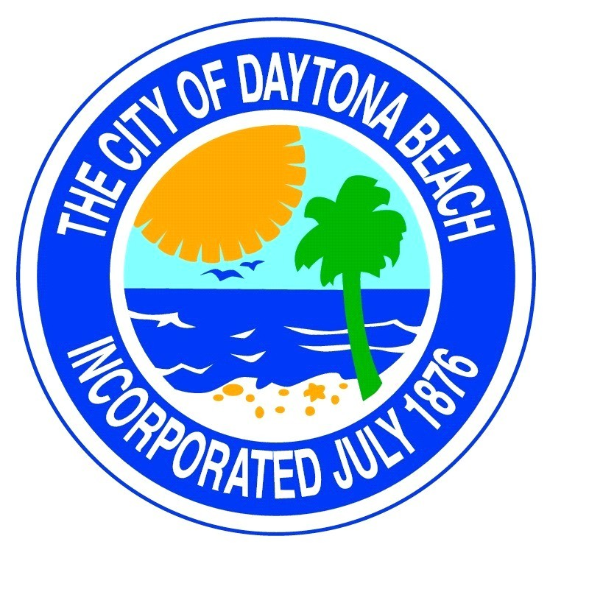
Downtown Development
Authority Board Meeting
Thursday
Feb. 24th., 2022
8:00 a.m.
at
Commission Chambers

