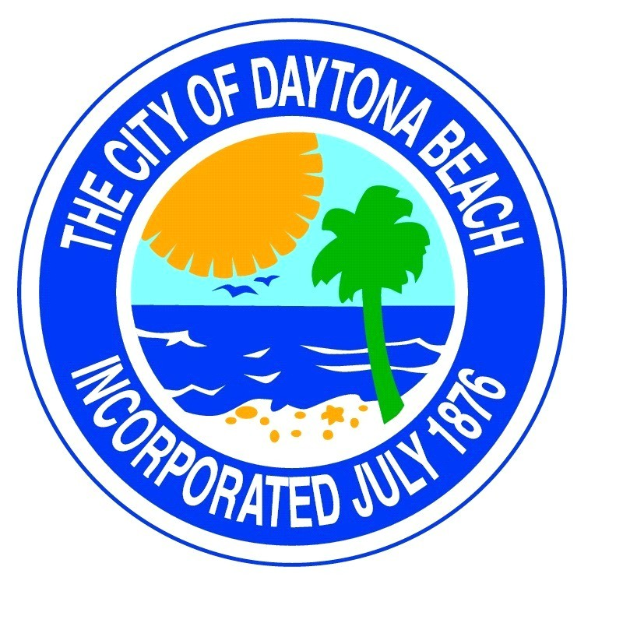
Downtown Development
Authority Board Meeting
Thursday
November 10, 2022
8:00 a.m.
In
Room 149B
CANCELLED
Due to Hurricane Nicole

