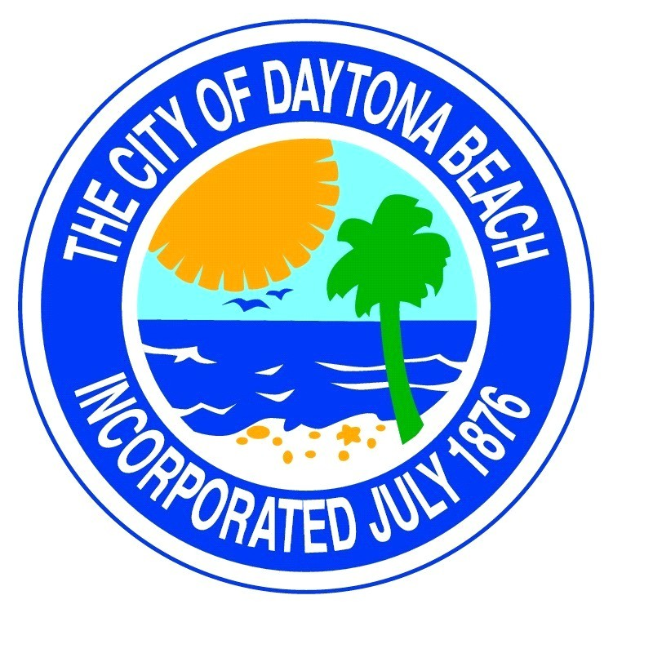
Downtown Redevelopment
Board Meeting
Tuesday
Jan 3rd., 2024
12:00 p.m.
at
Commission Chambers
Cancelled

