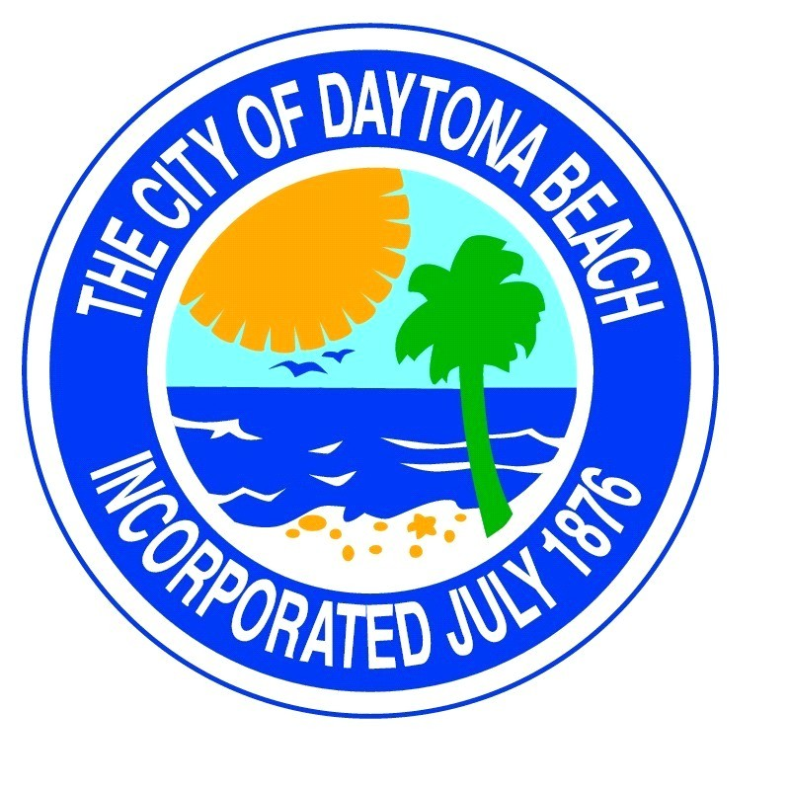
Downtown Development
Authority Meeting
Thursday
January 11, 2024
3:00 p.m.
in
Room 149 - Cancelled

