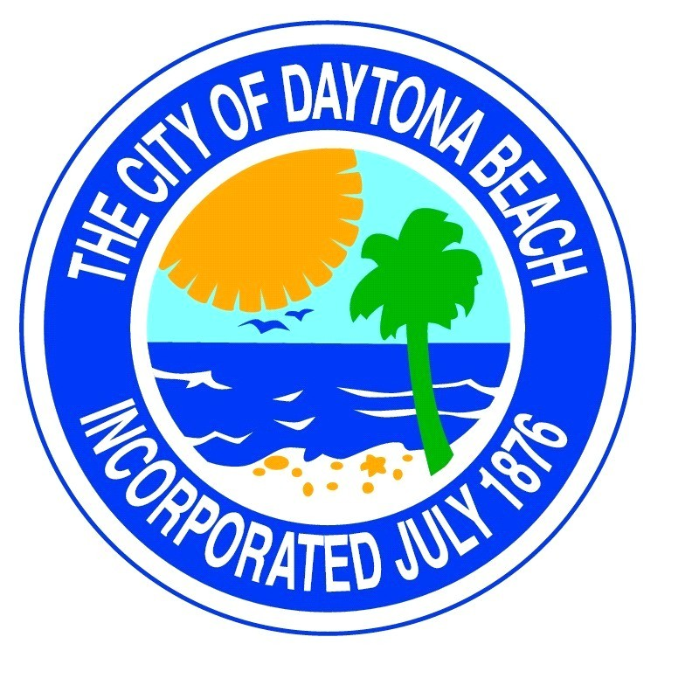
Midtown Redevelopment
Board Meeting
Tuesday
Jan 9th., 2024
6:00 p.m.
at
Commission Chambers
cancelled

