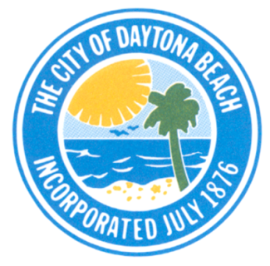 | The CITY OF DAYTONA BEACH  Historic Preservation Board Agenda  September 18, 2018
City Hall 301 South Ridgewood Avenue
Regular Meeting Tuesday, September 18, 2018
Commission Chambers 6:00 P.M.
Help for people with hearing impairments is available through the Assistive Listening System. Receivers can be obtained from the Video Assistant.

Notice: Anyone wishing to appeal a final decision of the Historic Preservation Board will need a record of the proceedings. Interested persons may wish to ensure that a verbatim record of the proceedings before the Board is made, including any testimony or evidence presented to the Board. The City does not prepare or provide a verbatim record of Board proceedings.

1) Call to Order
2) Roll Call
3) Approval of Minutes: July 17, 2018 & August 21, 2018 Meetings
4) Action Item: (Quasi-Judicial Hearing):
DEV2018-126 COA for Renovation of a Contributing structure in the Seabreeze Local Historic District. 837 N. Oleander Avenue
5) Discussion Item: Preservation Award S. Ridgewood Elementary (747 Building)
6) Discussion Item: Preservation Award Halifax Historical Society Review of Certificate
7) Discussion Item: Scholarship Project
6) Other Business:
(a) Heritage Preservation Trust Report: Mr. Trager, Liaison
7) Staff Update
8) Public Comments
9) Board Comments
10) Adjourn

Next Meeting – October 16, 2018, 6:00 p.m. in the City Commission Chamber

