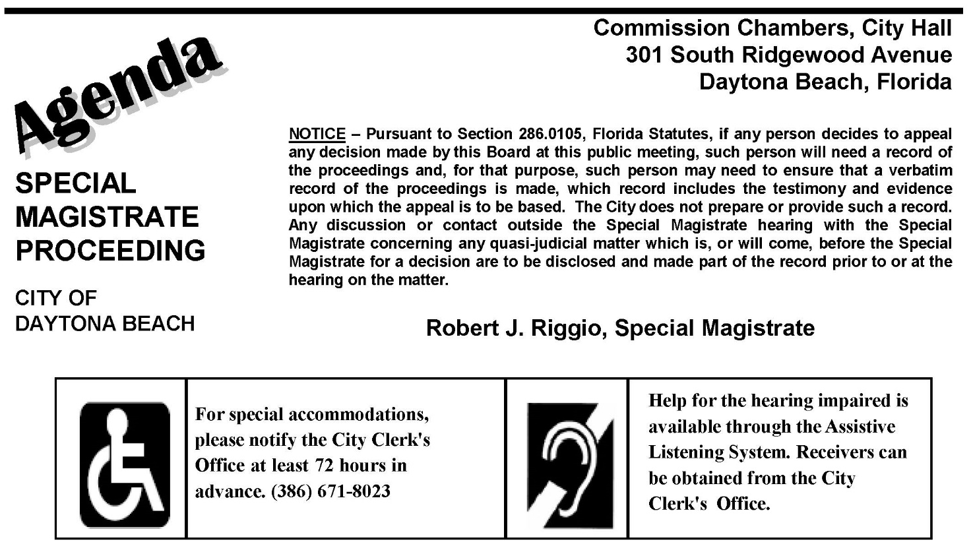

In accordance with the Americans with Disabilities Act (ADA), persons with a disability needing a special accommodation to participate in the Special Magistrate meeting should contact the City Clerk’s Office, 301 S Ridgewood Ave, Room 210, Daytona Beach, FL, 32114, Ph: (386) 671-8023, Email: clerk@codb.us not later than 72 hours prior to the proceeding. If you are hearing or voice impaired, contact the relay operator at 7-1-1 or 1-800-955-8771.

June 24, 2025 - 9:00 am
Rental Program

1. Call to Order

2. Announcements

3. Approval of the May 27, 2025 Meeting Minutes

4. Hearing of Cases

5. Lien Review
LR-1

RTL 01-25-03 - 145 Boysenberry LN - Tibor and Lidiko Benke is cited for failure to correct violations of LDC Art. 4 Sec. 4.1.A; Art. 5 Sec. 5.2.A.2, at Violation(s) – Zoning violation - the property is zoned PD-G. Short term rentals, known as "Other Accommodations" are not a permitted use in the zoning district. First Notified – 12/6/2024. Order Imposing Fine/Lien in the amount of $1,000.00 effective January 31, 2025. Compliance = December 12, 2024. Amount due $1,000.00 less $20 payment made ????, $10 payment made ??? etc = $960.00 due.

DISPOSITION_______________________________________________________________
(Kevin Yates)

NEW CASES: IRREPARABLE/IRREVERSIBLE

CASE # 1 - RTL 06-25-32 - Mike Willlams and Jennifer Ellis is cited for failure to correct violations of LDC Art. 4 Sec. 4.1.A; Art. 5 Sec. 5.2.A.2, at 124 Loomis Ave.
Violation(s) – Zoning violation - the property is zoned RDD6. Short term rentals, known as "Other Accommodations" are not a permitted use in the zoning district.
First Notified – 5/28/2025.

ACTION TO BE TAKEN: Impose Fine. IRREPARABLE/IRREVERSIBLE

DISPOSITION_______________________________________________________________
(Kevin Yates)

CASE # 2 - RTL 06-25-33 - Tatyana Naomy Barreto Ramos is cited for failure to correct violations of LDC Art. 4 Sec. 4.1.A; Art. 5 Sec. 5.2.A.2, at 274 Reena Dr.
Violation(s) – Zoning violation - the property is zoned PD-G. Short term rentals, known as "Other Accommodations" are not a permitted use in the zoning district.
First Notified – 6/3/2025.

ACTION TO BE TAKEN: Impose Fine. IRREPARABLE/IRREVERSIBLE

DISPOSITION_______________________________________________________________
(Kevin Yates)

CASE # 3 - RTL 06-25-34 - Eshaan Anil Patil is cited for failure to correct violations of LDC Art. 4 Sec. 4.1.A; Art. 5 Sec. 5.2.A.2, at 2102 Green Valley St.
Violation(s) – Zoning violation - the property is zoned PD-G. Short term rentals, known as "Other Accommodations" are not a permitted use in the zoning district.
First Notified – 5/30/2025.

ACTION TO BE TAKEN: Impose Fine. IRREPARABLE/IRREVERSIBLE

DISPOSITION_______________________________________________________________
(Kevin Yates)

CASE # 4 - RTL 06-25-35 - Justin Carloni is cited for failure to correct violations of LDC Art. 4 Sec. 4.1.A; Art. 5 Sec. 5.2.A.2, at 610 Roma St.
Violation(s) – Zoning violation - the property is zoned SFR-5. Short term rentals, known as "Other Accommodations" are not a permitted use in the zoning district.
First Notified – 5/21/2025.

ACTION TO BE TAKEN: Impose Fine. IRREPARABLE/IRREVERSIBLE

DISPOSITION_______________________________________________________________
(Kevin Yates)

CASE # 5 - RTL 06-25-36 - Wendy Dee Scorpio is cited for failure to correct violations of LDC Art. 4 Sec. 4.1.A; Art. 5 Sec. 5.2.A.2, at 4131 Calusa Pine Rd.
Violation(s) – Zoning violation - the property is zoned PD-G. Short term rentals, known as "Other Accommodations" are not a permitted use in the zoning district.
First Notified – 5/16/2025.

ACTION TO BE TAKEN: Impose Fine. IRREPARABLE/IRREVERSIBLE

DISPOSITION_______________________________________________________________
(Kevin Yates)

CASE # 6 - RTL 06-25-37 - Paul A Merk is cited for failure to correct violations of LDC Art. 4 Sec. 4.1.A; Art. 5 Sec. 5.2.A.2, at 346 Plaza Blvd.
Violation(s) – Zoning violation - the property is zoned MFR-40. Short term rentals, known as "Other Accommodations" are not a permitted use in the zoning district.
First Notified – 6/5/2025.

ACTION TO BE TAKEN: Impose Fine. IRREPARABLE/IRREVERSIBLE

DISPOSITION_______________________________________________________________
(Kevin Yates)

6. Miscellaneous Business

7. Adjournment

